

**Object Oriented Programming**

**Lab Task 4**

**SUBMITTED BY:**

Hasaan Ahmad SP22-BSE-017

**SUBMITTED TO: Sir Muzaffar Iqbal**

**Activity 1:**

package LAB4;

class ObjectPass {

    public int value;

    public static void increment(ObjectPass a) {

        a.value++;

    }

}

public class ObjectPassTest {

    public static void main(String[] args) {

        ObjectPass p = new ObjectPass();

        p.value = 5;

        System.out.println("Before calling: " + p.value); // output is 5

        ObjectPass.increment(p);

        System.out.println("After calling: " + p.value); // output is 6

    }

}

**Output:**

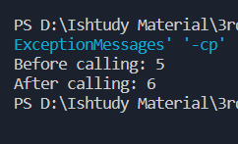

**Activity 2:**

package LAB4;

class Complex {

    private double real;

    private double imag;

    public Complex() {

        real = 0.0;

        imag = 0.0;

    }

    public Complex(double r, double im) {

        real = r;

        imag = im;

    }

    public Complex Add(Complex b) {

        Complex c_new = new Complex(real + b.real, imag + b.imag);

        return c_new;

    }

    public void Show() {

        System.out.println(real + imag);

    }

}

public class ComplexTest {

    public static void main(String args[]) {

        Complex C1 = new Complex(11, 2.3);

        Complex C2 = new Complex(9, 2.3);

        Complex C3 = new Complex();

        C3 = C1.Add(C2);

        C3.Show();

    }

}

**Output:**

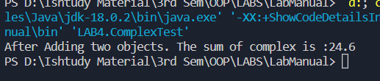

**Activity 3:**

package LAB4;

class Point {

    private int X;

    private int Y;

    public Point() {

        X = 5;

        Y = 6;

    }

    public Point(int a, int c) {

        X = a;

        Y = c;

    }

    public void setX(int a) {

        X = a;

    }

    public void setY(int c) {

        Y = c;

    }

    public int getX() {

        return X;

    }

    public int getY() {

        return Y;

    }

    public Point Add(Point Pa, Point Pb) {

        Point p_new = new Point(X + Pa.X + Pb.X, Y + Pa.Y + Pb.Y);

        return p_new;

    }

    public void display() {

        System.out.println(X);

        System.out.println(Y);

    }

}

public class PointTest {

    public static void main(String[] args) {

        Point p1 = new Point(10, 20);

        Point p2 = new Point(30, 40);

        Point p3 = new Point();

        Point p4 = p1.Add(p2, p3);

        System.out.println("Printing Point 1");

        p1.display();

        System.out.println("Printing Point 2");

        p2.display();

        System.out.println("Printing Point 3");

        p3.display();

        System.out.println("Printing Point 4 made by addition of point 2 and point 3 in point 1");

        p4.display();

    }

}

**Output:**

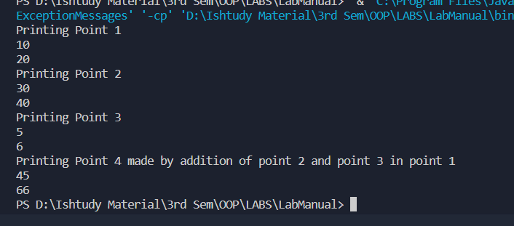

**Solved Lab Task 1:**

package LAB4;

public class DistanceCheck {

    public static void main(String[] args) {

        Distance d1 = new Distance(5.3, 2.3);

        Distance d2 = new Distance(2.3, 5.5);

        Distance d3 = d1.addTwoDistance(d1, d2);

        d1.display();

        d2.display();

        d3.display();

    }

}

class Distance {

    private double feet;

    private double inches;

    public Distance() {

        // Default Values for no arguments

        feet = 10;

        inches = 10;

    }

    public Distance(double feet, double inches) {

        this.feet = feet;

        this.inches = inches;

    }

    public double getFeet() {

        return feet;

    }

    public void setFeet(double feet) {

        this.feet = feet;

    }

    public double getInches() {

        return inches;

    }

    public void setInches(double inches) {

        this.inches = inches;

    }

    public Distance addTwoDistance(Distance d1, Distance d2) {

        double NewFeets = d1.feet + d2.feet;

        double newInches = d1.inches + d2.inches;

        Distance newDis = new Distance(NewFeets, newInches);

        return newDis;

    }

    void display() {

        System.out.println("Feets: " + this.feet);

        System.out.println("inches: " + this.inches);

    }

}

**Output:**

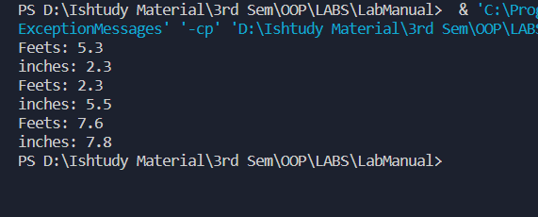

**Solved Lab Task 2:**

package LAB4;

/**

 * BookRunner

 */

class Book {

    String author;

    String[] chapterName = new String[10];

    public Book(String author, String[] chapterName) {

        this.author = author;

        this.chapterName = chapterName;

    }

    // For default constructor

    public Book() {

        this.author = "Unknown";

        this.chapterName[0] = "Unknown";

    }

    boolean compareBooks(Book b) {

        if (this.author == b.author) {

            return true;

        } else {

            return false;

        }

    }

    boolean compareChapterNames(Book b) {

        if (this.chapterName[0] == b.chapterName[0]) {

            return true;

        } else {

            return false;

        }

    }

    void display() {

        System.out.println("Author: " + this.author);

        System.out.println("Chapters: ");

        for (int i = 0; i < this.chapterName.length; i++) {

            System.out.println(this.chapterName[i]);

        }

    }

}

public class BookRunner {

    public static void main(String[] args) {

        Book b1 = new Book("Hasaan", new String[] { "Beginning", "Pilot", "Scene3" });

        b1.display();

        Book b2 = new Book("Mujtaba", new String[] { "Intro To Java", "CPP", "Hello World" });

        b2.display();

        // Declaring same book as 1 to check compare method

        Book b3 = new Book("Hasaan", new String[] { "Beginning", "Pilot", "Scene3" });

        System.out.println(b1.compareBooks(b3));

        System.out.println(b1.compareChapterNames(b3));

        // testing false results

        System.out.println(b1.compareChapterNames(b2));

    }

}

**Output:**

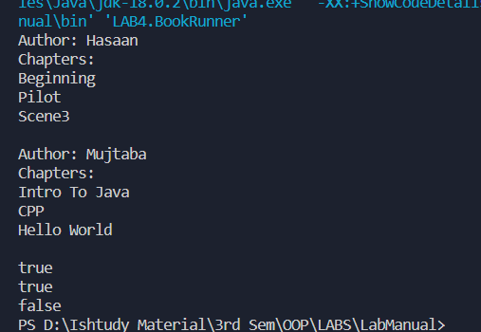

**Solved Lab Task 3:**

package LAB4;

class Fraction {

    private int numerator;

    private int denominator;

    public Fraction(int numerator, int denominator) {

        this.numerator = numerator;

        this.denominator = denominator;

    }

    public Fraction(int numerator) {

        this.numerator = numerator;

        this.denominator = 1;

    }

    public void setNumerator(int numerator) {

        this.numerator = numerator;

    }

    public void setDenominator(int denominator) {

        this.denominator = denominator;

    }

    public int getNumerator() {

        return numerator;

    }

    public int getDenominator() {

        return denominator;

    }

    public void display() {

        System.out.println(numerator + "/" + denominator);

    }

    public boolean equals(Fraction other) {

        return numerator * other.denominator == other.numerator * denominator;

    }

}

/**

 * FractionRunner

 */

public class FractionRunner {

    public static void main(String[] args) {

        Fraction f1 = new Fraction(4, 5);

        f1.display();

        Fraction f2 = new Fraction(5, 6);

        f2.display();

        System.out.println(f1.equals(f2));

        Fraction f3 = new Fraction(4, 5);

        System.out.println(f1.equals(f3));

    }

}

**Output:**

